**Introduction:**

Introducing the Powered Fire Extinguisher, a revolutionary fire safety solution powered by artificial intelligence (AI). This cutting-edge device combines advanced technology with the effectiveness of traditional fire extinguishers to provide an intelligent and efficient way to combat fires.

With AI capabilities, this fire extinguisher is equipped with sensors that can detect the presence of smoke, heat, and flames in real-time. The AI algorithms analyze the data collected from these sensors to accurately identify the type and intensity of the fire. This enables the device to respond swiftly and effectively, ensuring optimal fire suppression

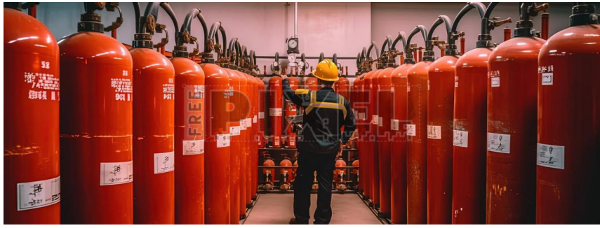

**Drone overview:**

Safety is paramount when it comes to fire prevention, which is why the Powered Fire Extinguisher incorporates multiple safety mechanisms. It has built-in fail-safe systems that prevent accidental discharge or malfunction. The device also includes advanced self-diagnostic capabilities, ensuring it remains in optimal working condition at all times.

Additionally, this intelligent fire extinguisher is designed to be user-friendly and accessible for everyone. It features an intuitive interface that provides clear instructions during emergency situations. The device can also be connected to a centralized monitoring system, allowing for remote monitoring and control.

**How can artificial intelligence detect fires, determine the type of fire, and extinguish the fire according to its type?**

Artificial intelligence (AI) in the Powered Fire Extinguisher utilizes a combination of sensors, data analysis, and machine learning algorithms to detect fires, determine their type, and extinguish them accordingly. Here's how it works:

Fire Detection: The device is equipped with various sensors such as smoke detectors, heat sensors, and flame detectors. These sensors continuously monitor the environment for any signs of fire. When they detect smoke, heat, or flames, they send real-time data to the AI system.

Data Analysis: The AI algorithms analyze the data collected from the sensors to determine if there is a fire present. By analyzing factors like the intensity of heat, presence of smoke particles, and characteristics of flames, the AI system can accurately identify whether a fire exists.

Fire Classification: Once a fire is detected, the AI system uses machine learning algorithms to classify the type of fire. It does this by comparing the collected data with a vast database of known fire patterns and characteristics. This allows the system to differentiate between different types of fires such as electrical fires, flammable liquid fires, or solid material fires.

Extinguishing Strategy: Based on the identified type of fire, the AI system determines the most effective extinguishing agent and strategy to combat that specific fire. Different types of fires require different approaches for effective suppression. For example, electrical fires may require non-conductive agents while flammable liquid fires may need foam or specialized suppressants.

Intelligent Suppression: The Powered Fire Extinguisher releases an appropriate extinguishing agent through its high-pressure nozzle directly at the source of the fire. The AI algorithms continuously monitor and adjust the flow rate and direction of the agent based on real-time feedback from sensors. This ensures that the extinguishing process is optimized for maximum effectiveness while minimizing collateral damage.

**Benefits of using artificial intelligence in fire extinguishers: Early detection:**

AI-powered fire extinguishers can detect fires at an early stage, even before they become visible or produce smoke. This allows for quicker response times and reduces the risk of the fire spreading.

Automatic activation: AI can enable fire extinguishers to automatically activate when a fire is detected, without the need for human intervention. This ensures a rapid response and minimizes the time it takes to suppress the fire.

Enhanced accuracy: AI algorithms can analyze various data inputs, such as temperature, smoke levels, and movement patterns, to accurately identify fires and distinguish them from false alarms. This reduces the chances of unnecessary activations and improves overall efficiency.

Real-time monitoring: AI-powered fire extinguishers can continuously monitor their surroundings and provide real-time updates on potential fire hazards. This allows for proactive measures to be taken, such as identifying areas prone to fires or detecting faulty equipment that may cause fires.

Remote control and management: AI technology enables remote control and management of fire extinguishers, allowing operators to monitor multiple devices from a central location. This simplifies maintenance tasks, facilitates troubleshooting, and ensures that all units are functioning properly.

Cost-effective solution: While initial implementation costs may be higher due to the integration of AI technology, the long-term benefits outweigh the investment. AI-powered fire extinguishers can help prevent extensive property damage, reduce insurance premiums, and potentially save lives.

**Conclusion:**

In conclusion, the use of artificial intelligence in fire extinguishers offers numerous benefits. It enables early detection of fires, automatic activation, enhanced accuracy in distinguishing fires from false alarms, real-time monitoring, remote control and management, data-driven insights, and cost-effective solutions. By leveraging AI technology, fire extinguishers become more efficient, responsive, and reliable in preventing and suppressing fires. This ultimately enhances safety measures and reduces the potential for property damage and loss of life